|  |  |  |
| --- | --- | --- |
| **PowerBI Apps** | **PowerBI Apps Overview** | |
| Powerbi Apps can easily deploy a collection of purpose-built dashboards and reports to a large number of business users and empower them to make data-driven decisions. You can distribute to the whole organization or to specific people or groups. It creates multiple content packs from any workspace. But apps are 1:1 with workspaces. We believe that this change will make apps easier to understand and maintain over the long run. Power BI has been at the forefront of this change by enabling users to easily monitor and analyze their most important business metrics in real time. | |  |

**PowerBI Apps**

**Create an app workspace**

1. Open Workspaces, then click Create app workspace.

2. Give the workspace a name. If the workspace ID already exists, edit it to create a unique ID.

3. Give all members edit access and set the group to private.

4. Now add email addresses of people you want to collaborate with in creating the app. You can’t add group aliases, just individuals.

5. Decide whether each person is a member or an admin, and save.

Power BI creates the workspace and opens it. It appears in the list of workspaces you're a member of. Because you’re an admin, you can click the ellipsis (…) to go back and make changes to it, adding new members or changing their permissions.

It’s empty, so start adding content to it. Adding content is just like adding content to your personal workspace (My Workspace), except the other people in the workspace can see and work on it, too. You can upload or connect to files, or connect to services from other companies, just as you would in your own personal workspace.

**Note**: You can only publish an app from an app workspace – you can't use My Workspace to publish apps.

## Distribute an app

When you’ve finished creating and perfecting the dashboards and reports in your app workspace, you can publish the app to your end users.

1. In the workspace, click the **Publish app** button in the upper right to start the process of sharing all the content in that workspace.

 First on **Details**, fill in the description to help people find the app. You can set a background color to personalize it. The app automatically uses the image of the workspace as the image for the app.

Next, on **Content**, you see the content that’s going to be published as part of the app – everything that’s in that workspace. You can also set the landing page – the dashboard or report people will see first when they go to your app. You can choose None. Then they’ll land on a list of all the content in the app.

**Note: Content that originated from copying an organizational content pack cannot be published as part of an app.**

4. The last step is to decide who has access to this app: either everyone in your organization, or specific people or groups, defined by their email.

5. When you click **Finish**, you see a message confirming it’s ready to publish.

6. In the success dialog box, you can copy the URL that’s a direct link to this app, and send it to the people you’ve shared it with.

**Installing the app**

End users can install the app in a couple of ways.

First, you can share that URL with them. The first time they go to the URL, they’re asked if they want to install the app. If they click **Add**, it’s added to the Apps section of their Power BI site.

Second, they can click **Get apps** in the Apps section of the Power BI service. Microsoft AppSource opens, where they see all the apps that have been shared with them, including the app that you most recently shared with them. If the organization has a lot of apps, they may need to search for it.

Either way, after that whenever they go to Apps, they’ll see this app in their list.

They can also install the app from their iOS, Android, or Windows device by clicking the link in the email. The app installs automatically and opens in the default landing page.

## Update your published app

You can make changes to the app by navigating to the corresponding app workspace.

1. Open the workspace where you created the app.

2. You can make any changes you want to the dashboards and reports in the app.

**Note: These changes are not pushed to the app until you publish again. This lets you make changes without affecting the published apps.**

3. Once you are happy with the content, go back to the app workspace list of contents and click **Publish app**.

4. Update **Details**, **Content**, and **Access**, if you need to, then click **Update app**.

## Unpublish the app

To unpublish an app, click the “…” icon and select Unpublish app. The app will be removed from Microsoft AppSource and is inaccessible by end users.

# Publish App in Power BI

In this article, we will show you the step by step approach to Publish App in Power BI with practical example. Before we start publishing Power BI app, let me show you the existing dashboards in my [Power BI](https://www.tutorialgateway.org/power-bi-tutorial/) workspace.

For this demonstration, we are using Sample Workspace. I suggest you to refer [Create a Workspace](https://www.tutorialgateway.org/create-power-bi-workspace/) article to understand the workspace creation.

Please click on the [Power BI](https://www.tutorialgateway.org/power-bi-tutorial/) Sample Workspace, and then go to the dashboards tab to see the list of available [dashboards](https://www.tutorialgateway.org/create-a-power-bi-dashboard/). As you can see from the below screenshot, currently there is only one dashboard in this workspace.

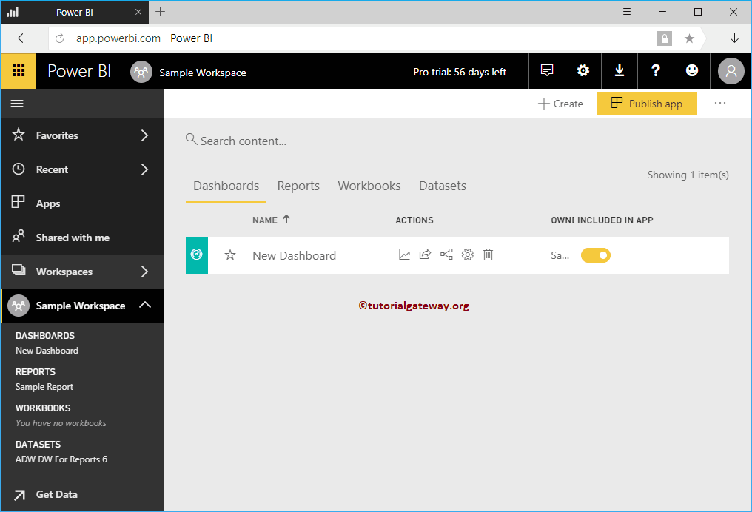

## How to Publish App in Power BI

In order to publish app in Power BI, please click on the **Publish App** button on the top right corner as we shown below

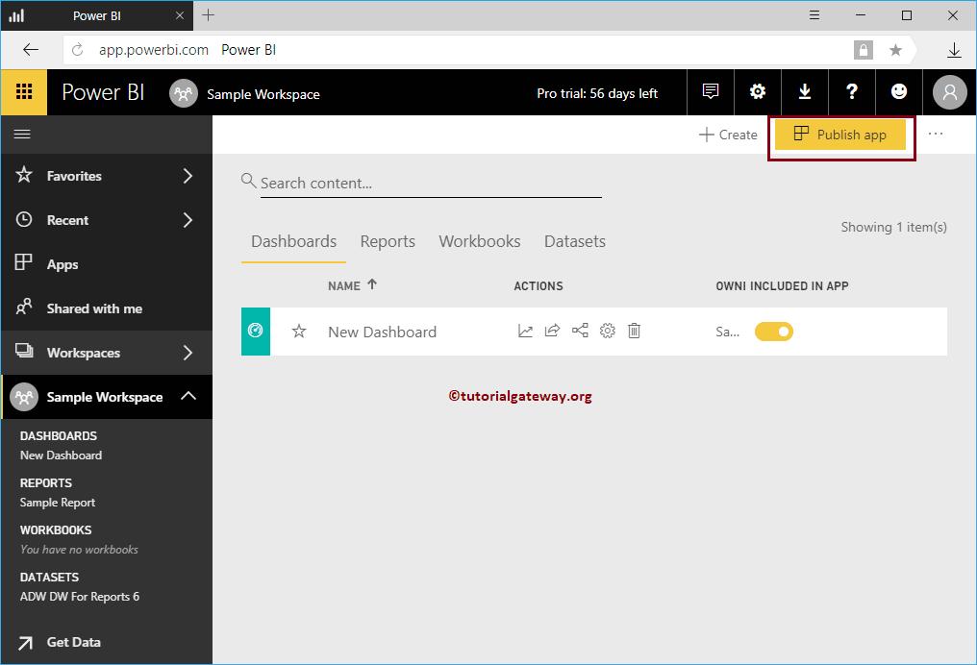

Clicking the **Publish App** button will open following window. Under the Details section,

* **Description:** Please provide a valid description about this app. This is required field so, you have to fill something here.
* **Background Color:** Please select the background color of this app. By default Green is selected.

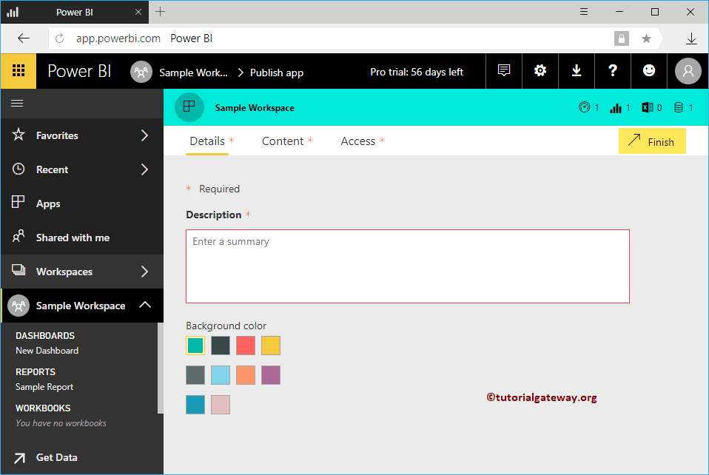

As you can see, we added the description, and changed the App color to red

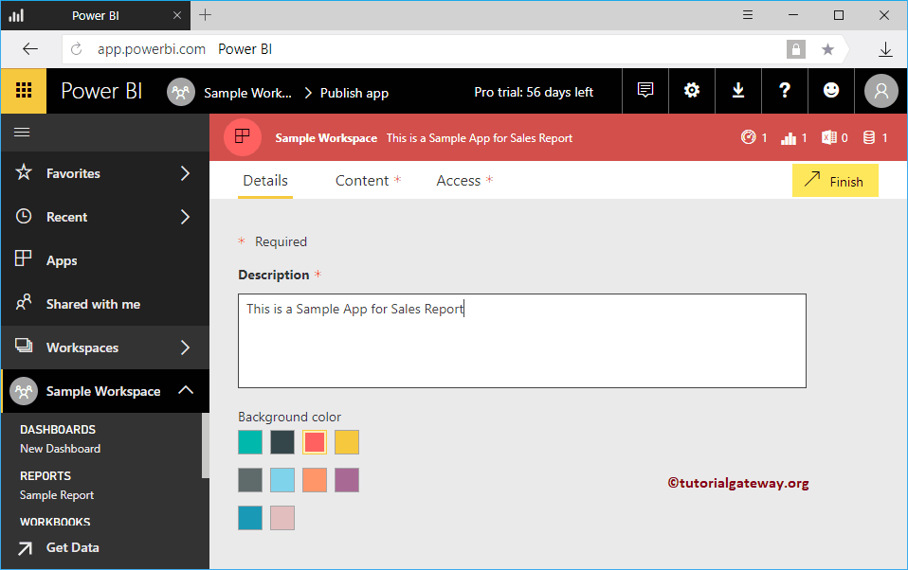

Under the Content tab, specify the App landing page

* **Specific Content:** If you select this option then use dropdown list to select dashboard
* **None:** There will be no landing page

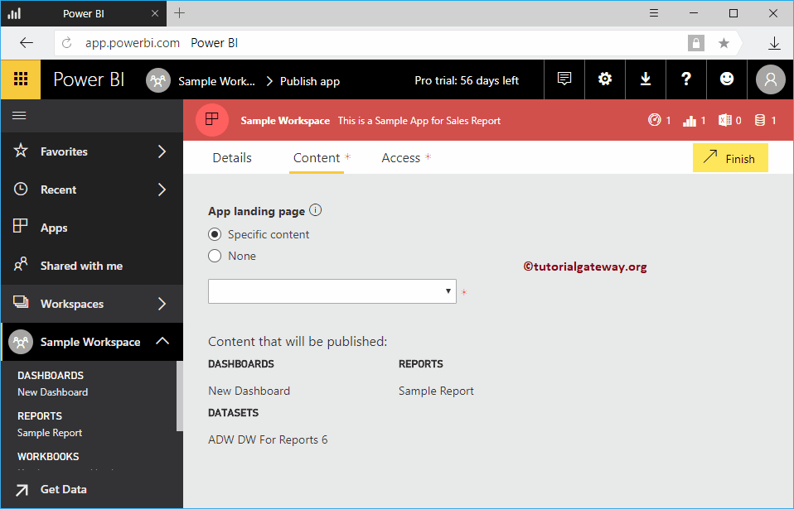

Let me select the New dashboard as the landing page

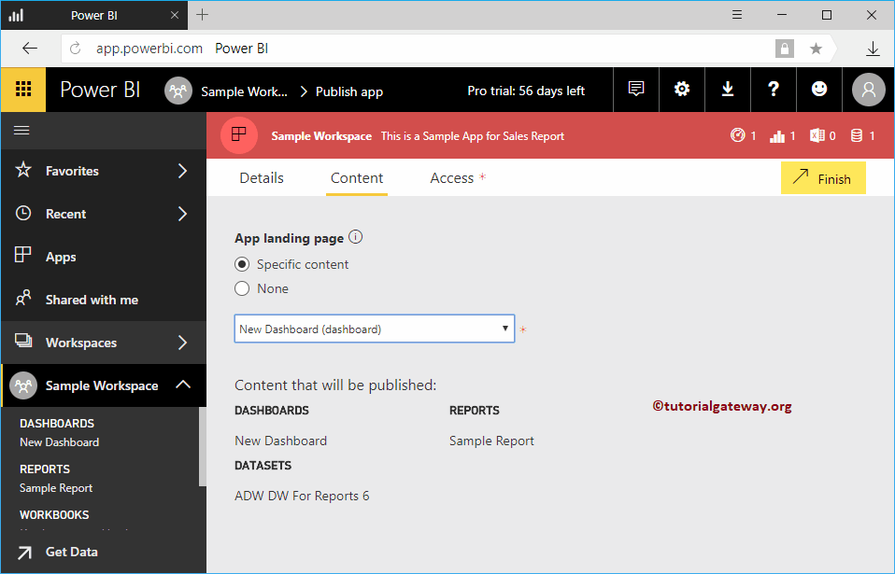

Under the Access tab

* **Permissions:** Either you can give access to the entire organization, or few individuals or group.

For this demo, we selected Specific individual or group, and added Kishore

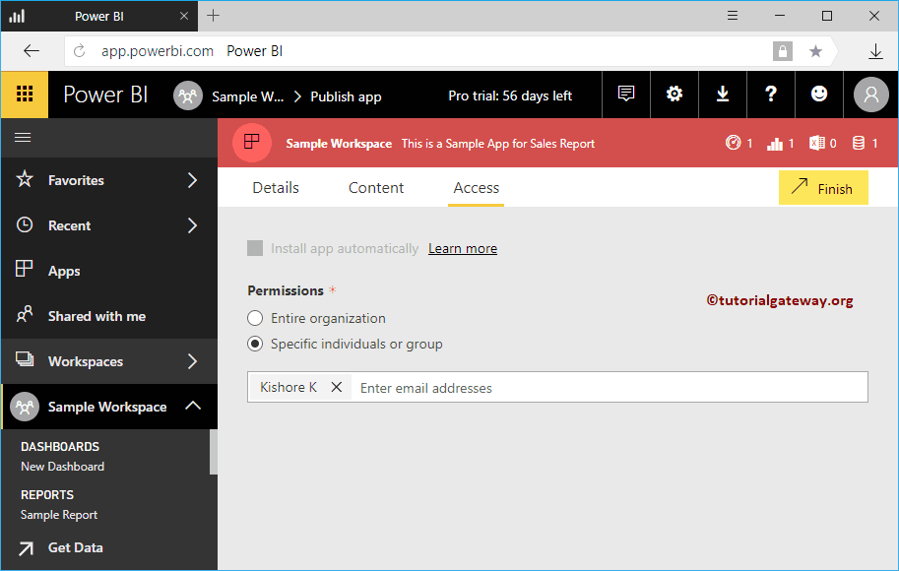

Once you are done, please click Finish button

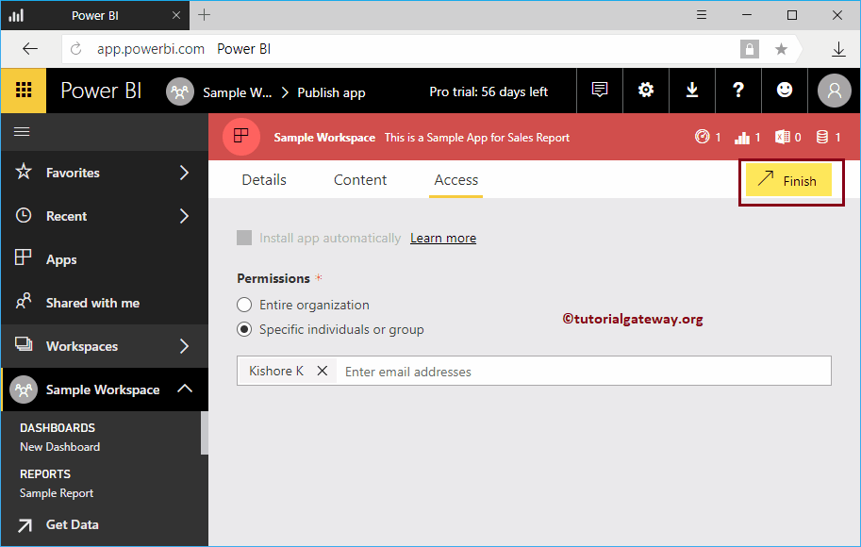

Click Publish button

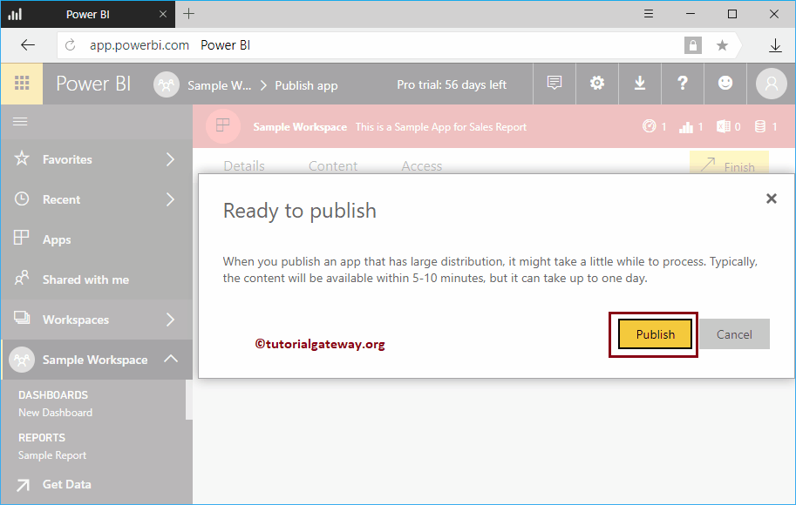

Please save link. This link will help you to open the App. For now, let me click Get App button

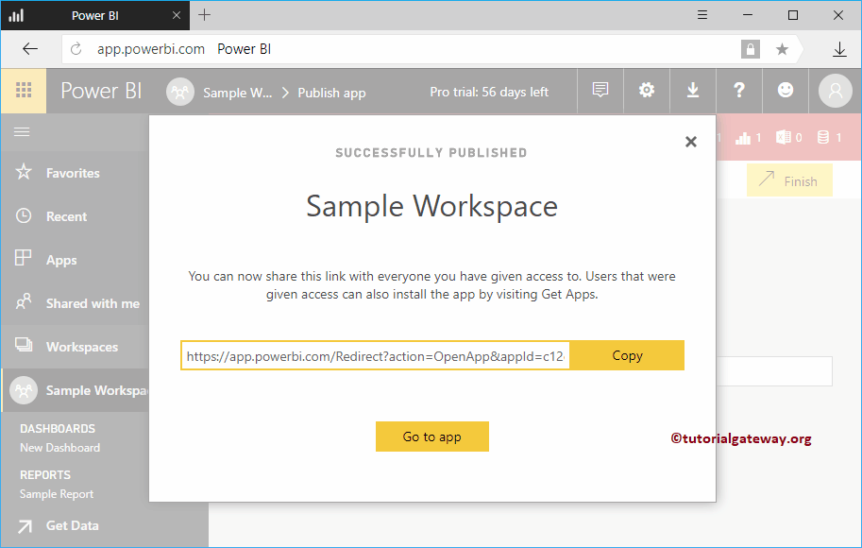

Clicking that button will take you to the following window. If this is not the case, click on the Apps tab inside the Left navigation bar.